**Sequence Analysis Lab 1**

**Document Id 28**

A slice is part of an array

A section of a slice may hold another slice.

<https://en.wikipedia.org/wiki/Maximum_subarray_problem>

A pair of integers (i, j), such that 0 ≤ i ≤ j < n, is called a slice of array

The sum of a slice (i, j) is the total of seq[i] + seq[i+1] + ... + seq[j].

int sequence[ ] = {3, 2, 6, -1, 4, 5, -1, 2 };

(1, 6) = { 2, 6, -1, 4, 5, -1 };

Application of slice in scanning technology

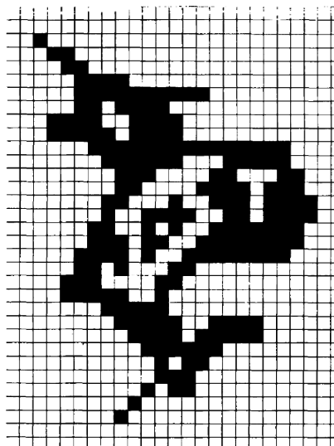

Store row 6 as bitmap

(0, 5) -> ! (5, 8) -> (9, 22) !(i, j) => black

Double-slice are algorithms that are employed in image scanning contexts to

optimise storage and efficiency

A triplet (i, j, k), such that 0 ≤ i < j < k < n, is called a double slice.

(i, j, k ) = { seq[i + 1] , seq[i + 2],... , seq[j − 1] , seq[j + 1] ,... seq[k − 1] }

{3, 2, 6, -1, 4, 5, -1, 2 }

(0, 3, 6) = {2 , 6 , 4 , 5 }

Note { 6 } = seq[j-1] = seq[i+2]

maximum sum subarray with one element missing

**seq[j − 1] , seq[j + 1]**

**Practical Task Application of a slice operation**

Convert the the maximum sum subsequence problem to that of

taking the profit or loss between consecutive days by

1. So you would transform a list of values

{2, 1, 3, 4, 1, 2, 1, 5, 4}

into a list of gains/losses

1. Find the max gain